|  |  |  |
| --- | --- | --- |
| OP_logo_H_cmyk |  | College of Engineering  Bachelor of Information Technology |

Course Directive

IN726001 Data Science and Machine Intelligence

Semester 1, 2019

# Description

This course aims to provide a broad introduction to Machine Intelligence and Data Science with an emphasis on the intuition and the applications behind the concepts. Students will be able to analyze a data problem and based on a reasoned argument choose and deploy the appropriate machine learning tool to solve the problem and obtain useful/actionable information from the raw data. Possible applications are: pattern recognition, medical diagnosis, recommender systems, anomaly detection, natural language understanding, autonomous navigation, clustering, predictive systems, biometrics and a myriad of others.

# Course Information

Credits 15 credits

Prerequisites IN605001 Databases 2

If you have not passed this paper then you must obtain a waiver before attending the course.

# Lecturer

|  |  |
| --- | --- |
| Name | David Rozado |
| Role | Senior Lecturer |
| Location | D309 |
| Phone | 479-6075 |
| email | david.rozado@op.ac.nz |

# Course Dates

|  |  |
| --- | --- |
| Term 1 (8 weeks) | 18 February – 12 April |
| Mid semester break | 13 April – 28 April |
| Term 2 (5 weeks) | 29 April – 21 June |

# Course LOCATION AND TIMES

Monday: 15:00-17:00 in D312

Wednesday: 13:00-15:00 in D312

# Learning OUTCOMES

At the successful completion of this course, students will be able to:

1. Analyse the principles, advantages, limitations and possible applications of machine learning
2. Generate solutions to solve machine learning problems and design and implement test procedures in order to evaluate the model.
3. Adapt mathematical intuition from Linear Algebra, Probability and Statistics to machine intelligence
4. Apply data mining techniques to fetch, scrub, explore, visualize, model, evaluate, and interpret data

# Resources

* Course content
  + I:\COURSES\ITP\BITY3\IN726-dsmi
  + <https://github.com/OPClasses2/IN726-dsmi> (If you want to use the GitHub repository for fetching course content, send me your GitHub username via personal message in Slack)
* Microsoft Teams channel:
  + [IN726 - Machine Intelligence](https://teams.microsoft.com/l/channel/19%3a4a7312d6b7d045ecb5333d381c973b7d%40thread.skype/IN726%2520-%2520Machine%2520Intelligence?groupId=c18b709a-5c04-4890-9c83-3963ca65b0b8&tenantId=450e6824-88ab-4ad2-914d-b0f385da600c)

Please refer any problems with libraries or frameworks to Rob Broadley, Head Technician. (rob.broadley@op.ac.nz)

* **Textbook**

There is no required textbook for the course.

Required readings will be provided digitally.

# Tentative Schedule

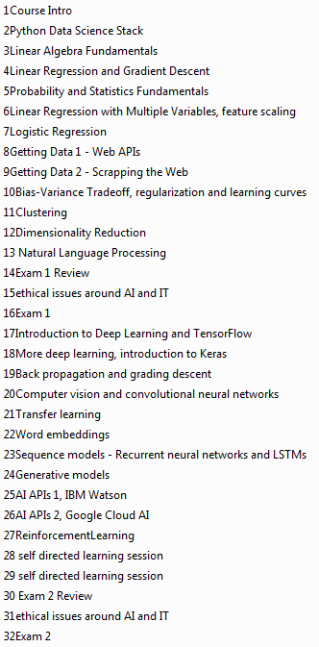

# AssessmenTs

|  |  |  |
| --- | --- | --- |
| Assessment | Weight | Learning outcomes |
| Assignment 1 | **25%** | **1, 2, 3, 4** |
| Assessment 1 | **25%** | **1, 2, 3** |
| Assignment 2 | **25%** | **1, 2, 3, 4** |
| Assessment 2 | **25%** | **1, 2, 3** |

### Submission requirements

* Detailed assignment requirements, including instructions for submission, will be provided for each assessment.
* Assignment must be submitted by 5.00 PM of the due date unless otherwise specified.
* Late assignments will be penalised 10% (percentual points) of the raw mark for each day late (including weekends)
* Students should keep a copy of all submitted work.

**Course Requirements and Expectations**

**Criteria for Passing**

# To pass this paper, you must achieve an overall average of 50. There must be a genuine attempt at all assessments. There are no resits.

**Learning hours**

This course requires 150 hours of learning. This time includes 64 hours of timetabled class time, and 86 hours of self-directed reading, preparation and completion of assignment work.

**Attendance**

* Students are expected to attend all classes, both lectures and labs.
* If you miss a class you will need to get notes from another student.
* If you cannot attend for a few days for any reason, please contact your lecturer.
* You must turn up ready for assessments on the due date and at the correct time. No extra time will be scheduled. If you do not turn up, you have failed the assessment.

**Communication**

Your student email and the course slack channel are official communication channels. It is your responsibility to regularly check those for important course related material, including changes to class scheduling or assessment details. Not checking will not be accepted as an excuse.

**Snow Days/Polytechnic Closure**

In the event that the Polytechnic is closed or has a delayed opening because of snow or bad weather, you should not attempt to attend class if it is unsafe to do so. It is possible that your instructor will not be able to attend either, so classes will not physically be meeting. However, this does not become a holiday. Rather, material will be available on the I drive/GitHub repository covering the material for classes affected by the closure. You are responsible for any material presented in this manner. Information about closure will be posted on the Otago Polytechnic facebook page <https://www.facebook.com/OtagoPoly>.

**Group work and originality**

Students in the Bachelor of Information Technology degree are expected to hand in original work. Students are encouraged to discuss assignments with their fellow students, however, all assignments are to be completed as individual works unless group-work is ***explicitly*** required (i.e. if it doesn’t say it is group-work then it is not group-work – even if a group consultation was involved). Failure to submit your own original work will be treated as plagiarism.

**Referencing**

Appropriate referencing is required for all work. Referencing standards will be specified by your lecturer.

**Plagiarism**

Plagiarism is submitting someone else’s work as your own. Plagiarism offences are taken seriously and an assessment that has been plagiarised may be awarded a zero mark. A definition of plagiarism is in the Student Handbook, available online or at the School office.

**Submission requirements**

All assignments are to be submitted by the time, date, and method given when the assignment is issued. Failure to meet all requirements may result in a penalty of up to 10% per day (including weekends).

**Extensions**

Extensions are only available for unusual circumstances. These must be applied for, and approved, prior to the submission deadline.

**Impairment**

In case of sickness contact your lecturer or year co-ordinator as soon as possible, preferably before the test or assignment is due. The policy regarding the granting of a mark that considers impaired performance requires a medical certificate and a medical practitioners signature on a form. You may should refer to the guide on impaired performance on the student handbook.

**Appeals**

If you are concerned about any aspect of your assessment, please approach the lecturer in the first instance. We support an open door policy and aim to resolve issues promptly. Further support is available from Year Co-ordinators, Programme Manager and Head of School. Otago Polytechnic has a formal process for academic appeals if necessary.

**Other Documents**

Regulatory documents relating this course can be found on the Polytechnic website.